Review
by Sri Indrayani

Submission date: 15-May-2020 12:54PM (UTC+0700)
Submission ID: 1324773574
File name: Sri Indrayani_Review.docx (410.52K)
Word count: 1878
Character count: 12796

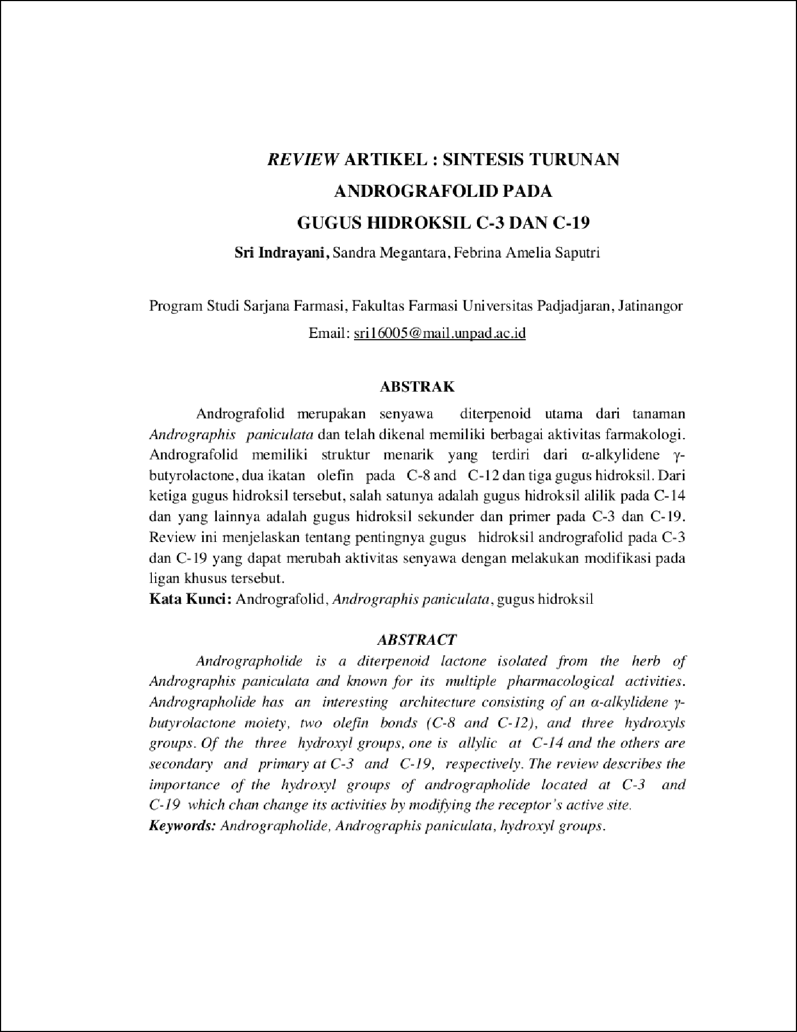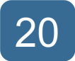

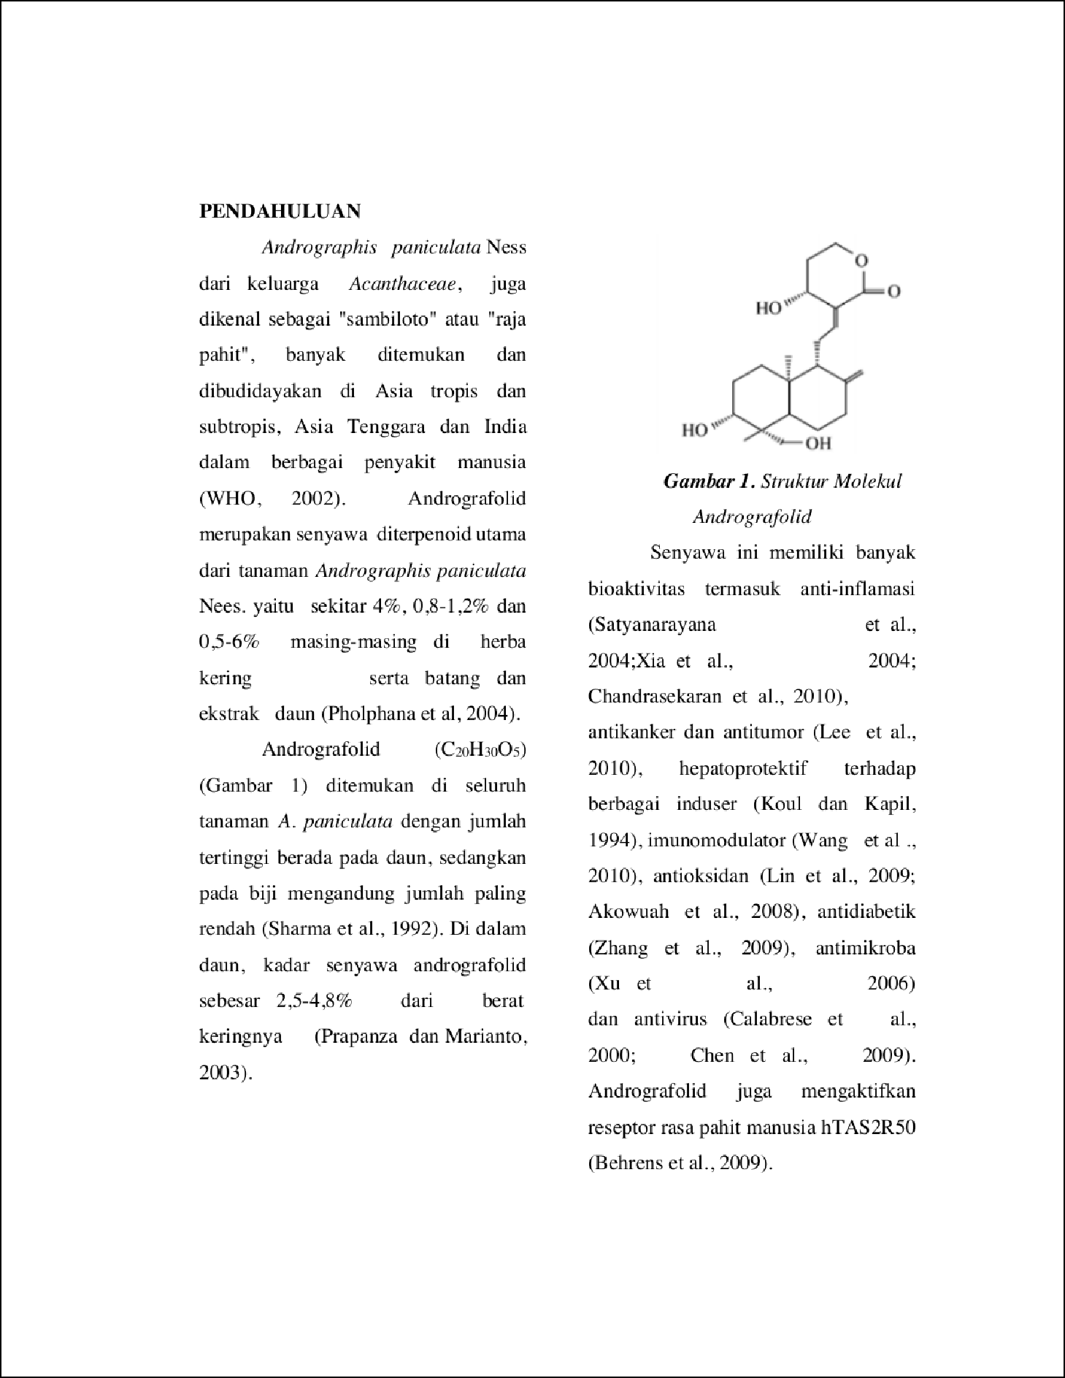

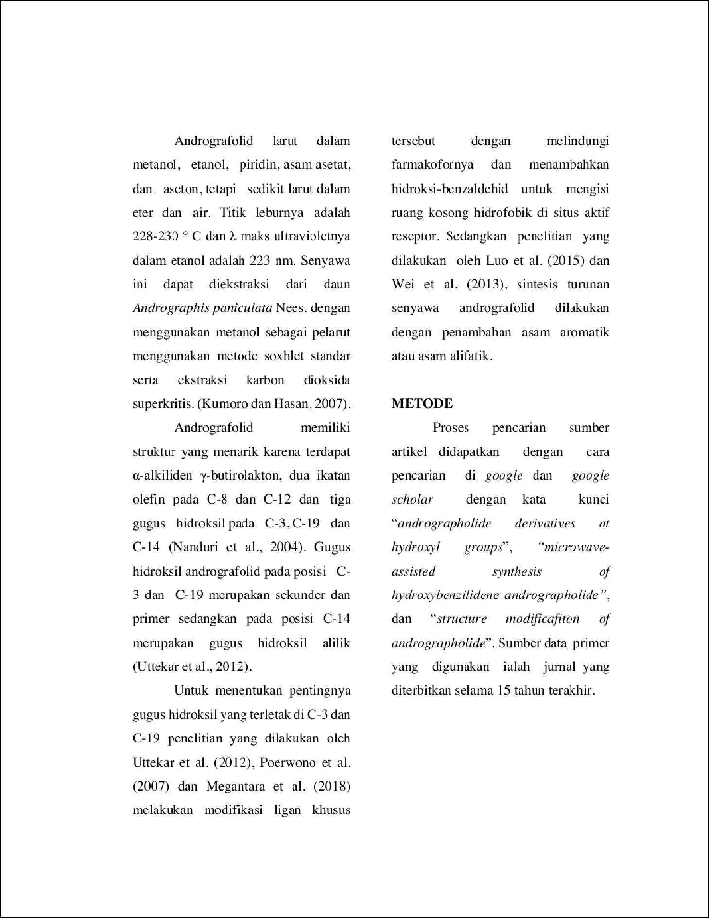

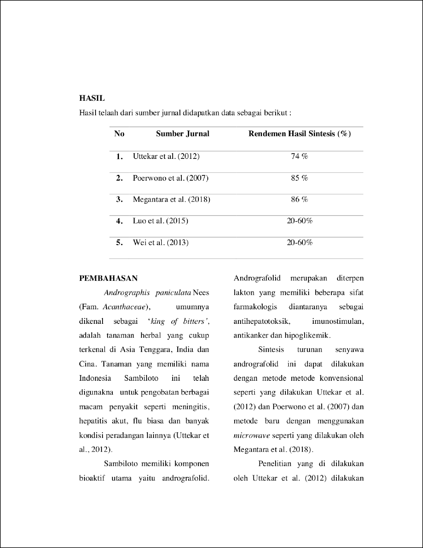

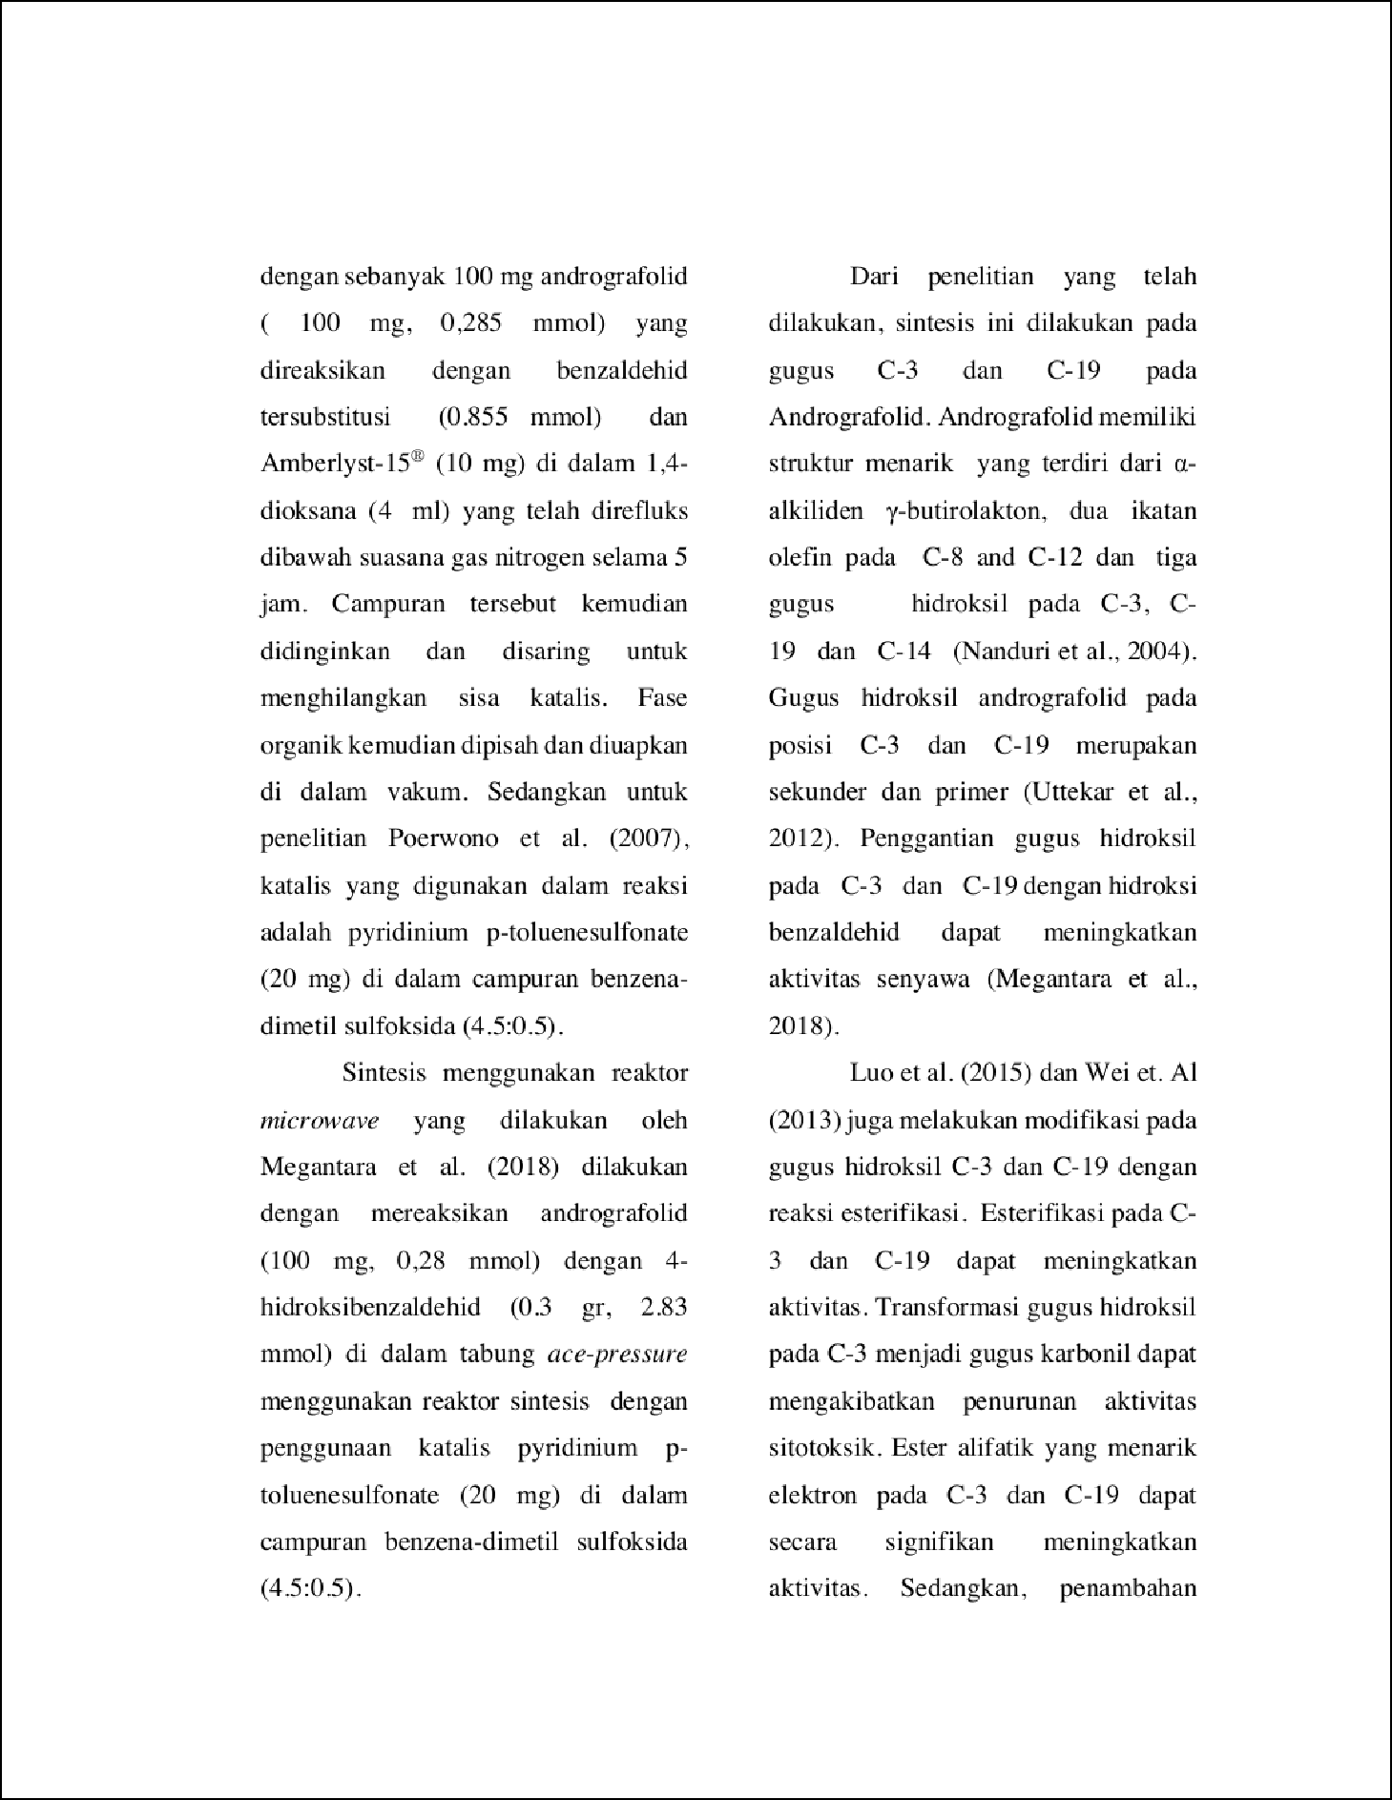

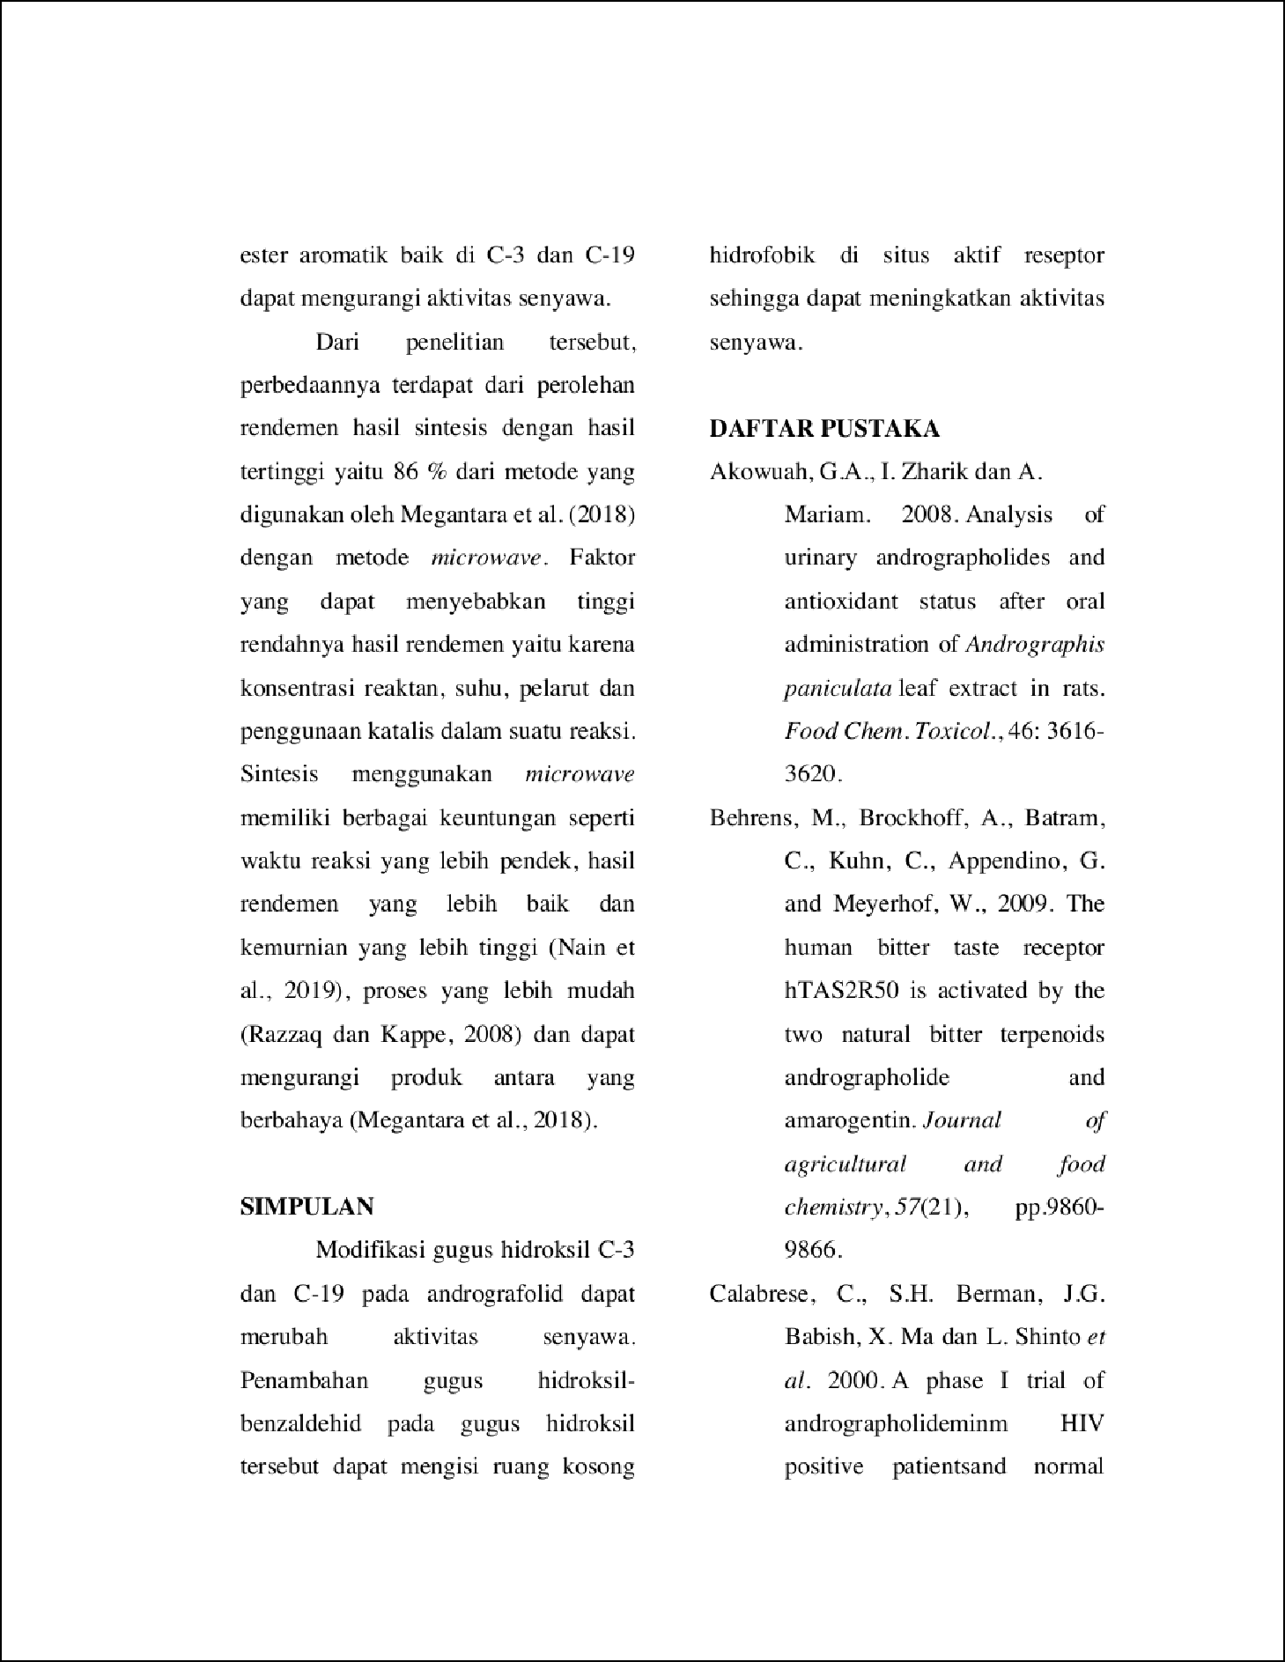

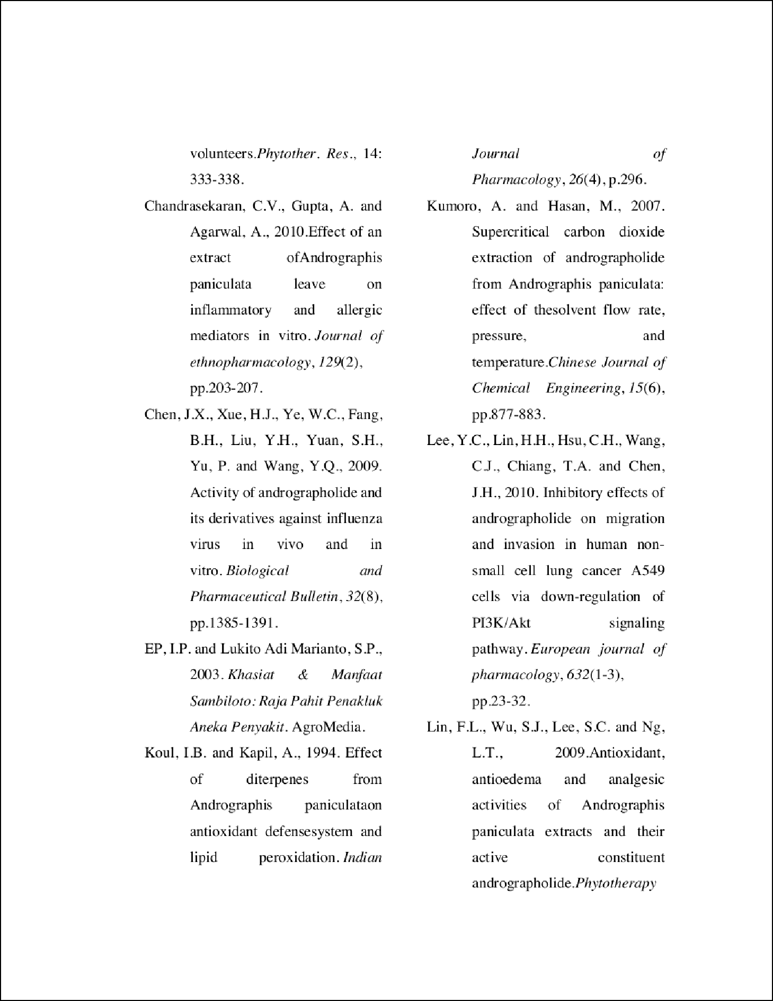

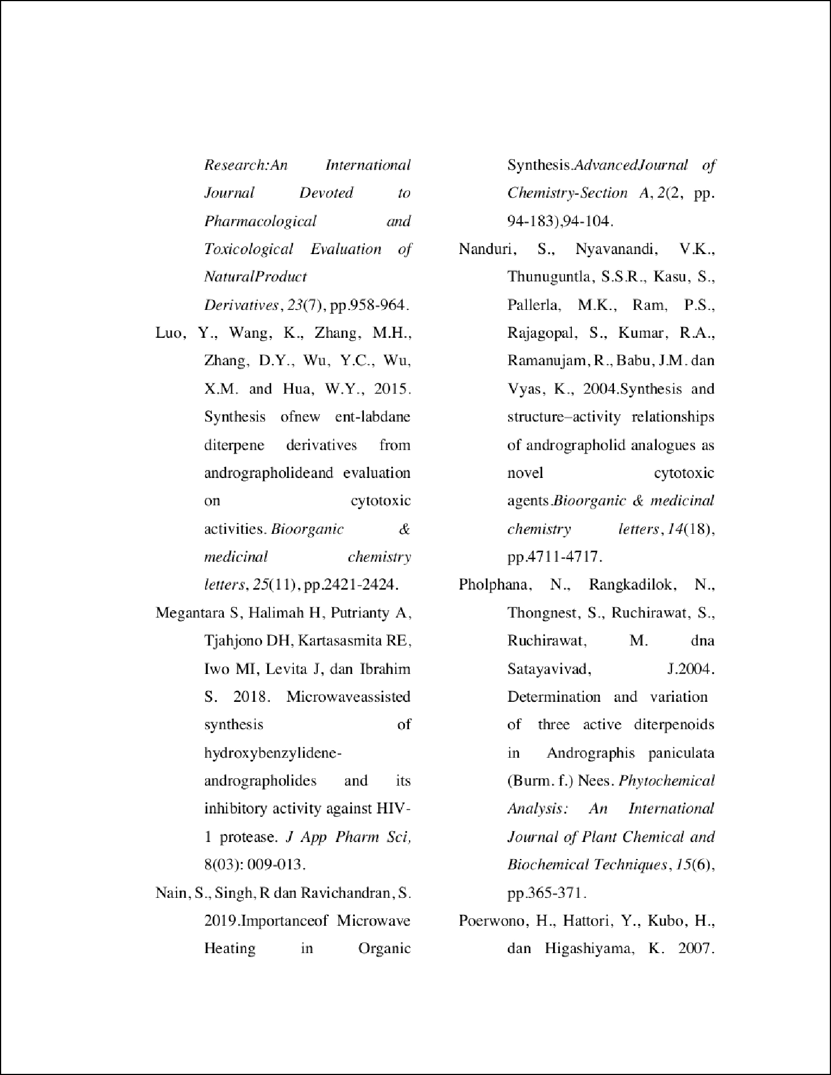

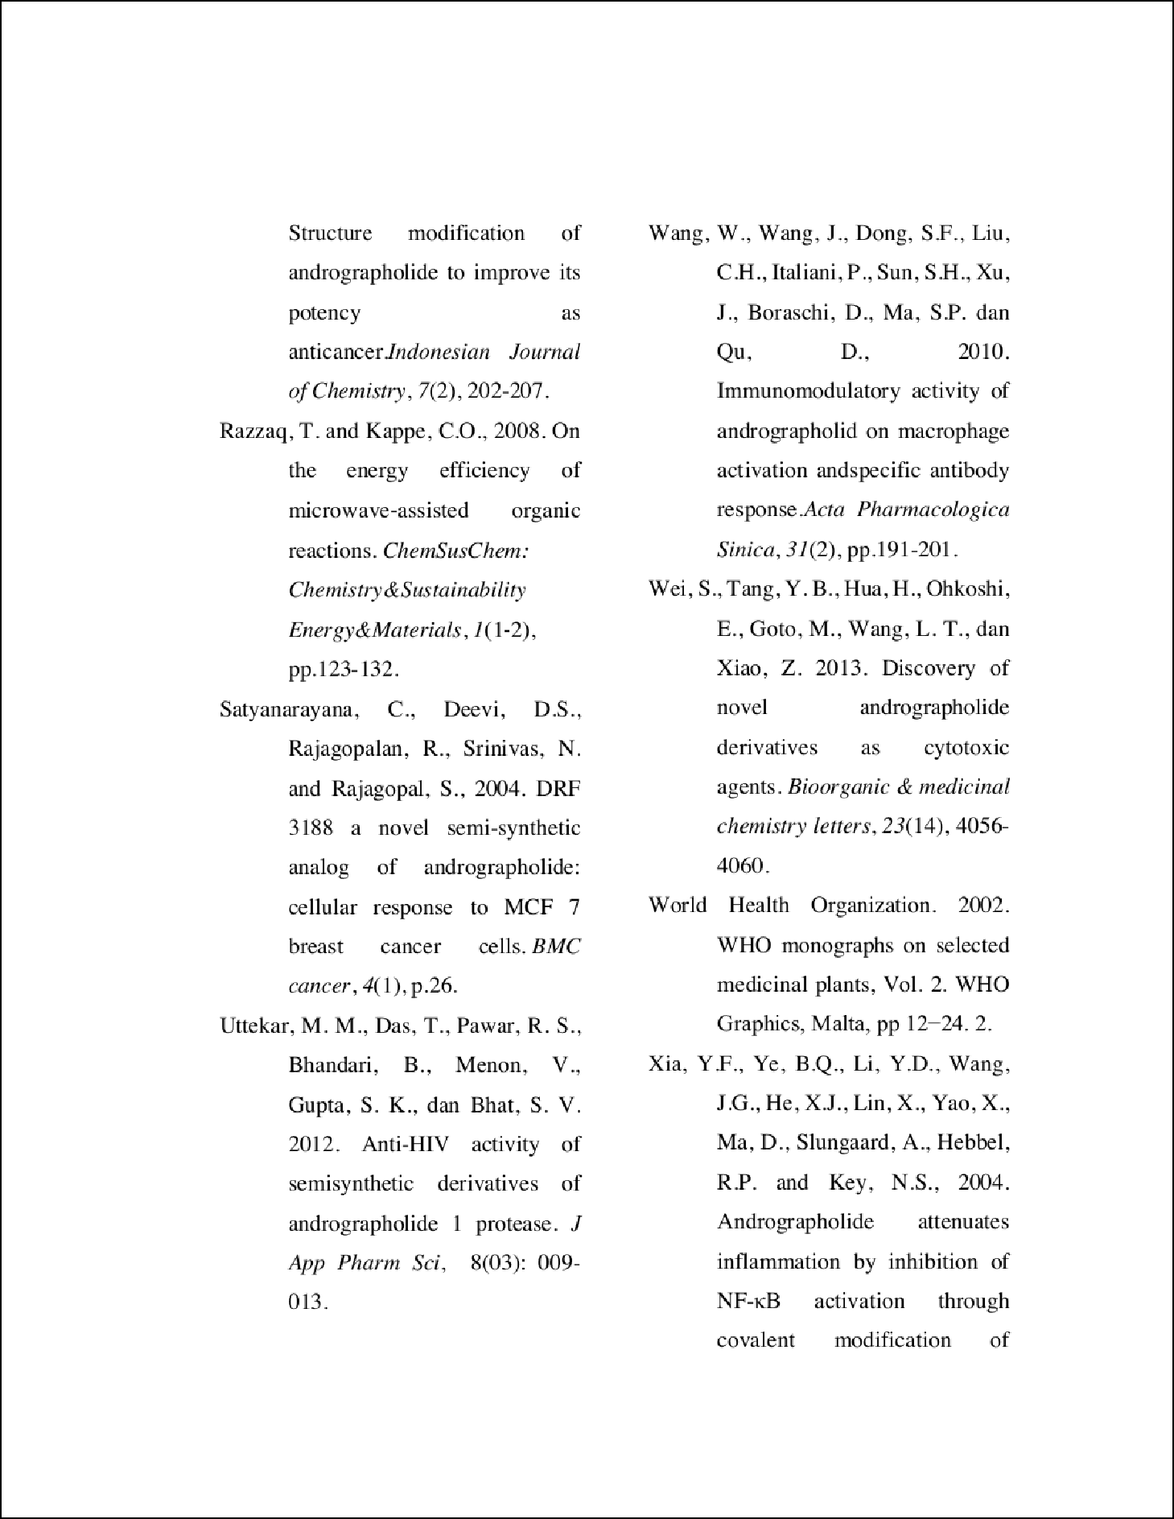

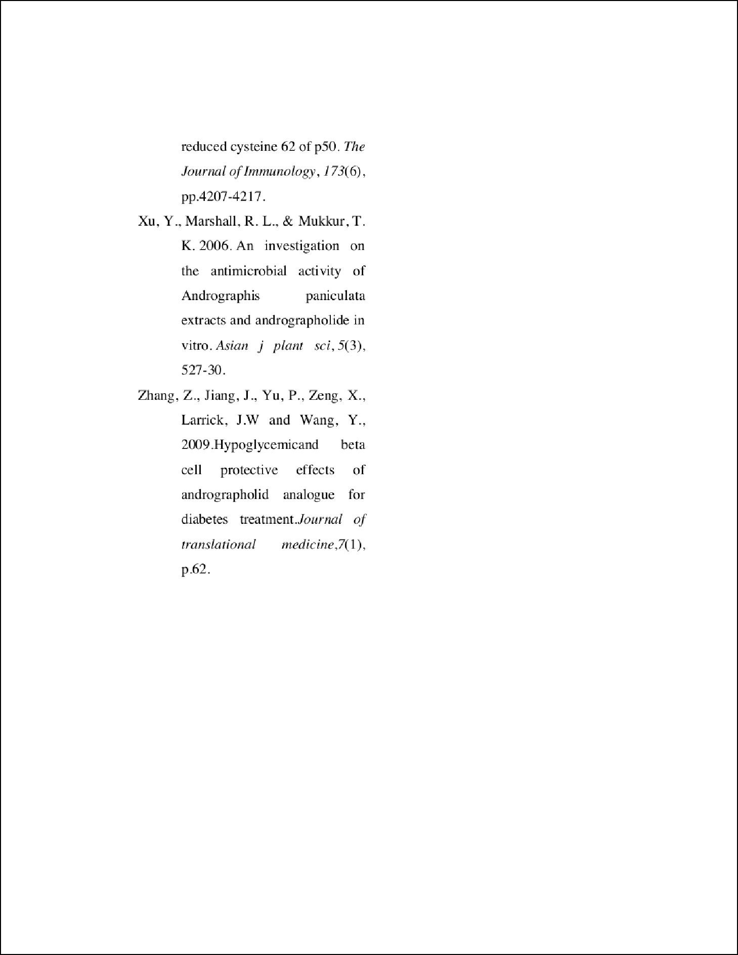

Review
ORIGINALITY REPORT
17% | 17% | 16% | 15%
SIMILARITY INDEX | INTERNET SOURCES | PUBLICATIONS | STUDENT PAPERS
PRIMARY SOURCES

ccsenet.org
1
2
Internet Source %
1%

2 Munipally Praveen Kumar, Estari Mamidala, Khalid A. Al-Ghanim, F. Al-Misned, Shahid Mahboob. "Evaluation of the andrographolides role and its indoleamine 2,3-dioxygenase inhibitory potential and attendant molecular mechanism against STZ-induced diabetic rats", Saudi Journal of Biological Sciences, 2020
Publication
1

psasir.upm.edu.my
Internet Source %
3

ifrj.upm.edu.my
Internet Source %
4
1
1%

5 Mushtaq T.B. AL-Zuhariy, Waleed H. Hassan. "Hepatoprotective and Immunostimulatory Effect of Ganoderma, Andrographolide and Turmeric Against Aflatoxicosis in Broiler Chickens", International Journal of Poultry Science, 2017
Publication

6

7

8

9

10

11

12

13

14

15
www.japsonline.com
Internet Source

Mun Ock Kim, Jee Hee Seo, Eun Bin Kwon, Myung Ji Kang, Su Ui Lee, Dong Oh Moon, Mi Kyeong Lee, Chul-Ho Lee, Hyun Sun Lee. " Exerts Lipid-Lowering Action in Both Normal and Hyperlipidemic Mice ", Natural Product Communications, 2018
Publication

Submitted to Mahidol University
Student Paper

mdanderson.influuent.utsystem.edu
Internet Source

Submitted to SVKM International School
Student Paper

www.airitilibrary.com
Internet Source

shodhganga.inflibnet.ac.in
Internet Source

Submitted to De Montfort University
Student Paper

ojs.unud.ac.id
Internet Source

scholarbank.nus.edu.sg
Internet Source
1%
1%

1%
1%
1%
1%
1%
1%
<1%
<1%

16

17

18

19

20

21

22

23
Andraos, John, and Andrew P. Dicks. "Green chemistry teaching in higher education: a review of effective practices", Chemistry Education Research and Practice, 2012.
Publication

eprints.undip.ac.id
Internet Source

"Plant-derived Bioactives", Springer Science and Business Media LLC, 2020
Publication

repositorio.ufsc.br
Internet Source

Venu Sharma, Tanwi Sharma, Sanjana Kaul, Kamal K. Kapoor, Manoj K. Dhar. "Anticancer potential of labdane diterpenoid lactone “andrographolide” and its derivatives: a semi- synthetic approach", Phytochemistry Reviews, 2016
Publication

medcapsules.com
Internet Source

farmasetika.com
Internet Source

link.springer.com
Internet Source
<1%

<1%
<1%

<1%
<1%

<1%
<1%
<1%

Exclude quotes On Exclude bibliography On
Exclude matches Off

